IFT 266 Introduction to Network Information Communication Technology (ICT)
Lab 39
Implementing a subnetted IPv6 addressing

Co-authored by Paul Krajicek

This lab follows on from Lab 33 where you created a subnetted IPv6 addressing scheme.

In this lab, you will implement this IPv6 addressing scheme.

Scenario
Your network administrator wants you to assign five /64 IPv6 subnets to the network in the topology you just created in packet tracer. Your task is to determine the IPv6 subnets and assign IPv6 addresses to the routers.

- Setup the following topology in Packet Tracer
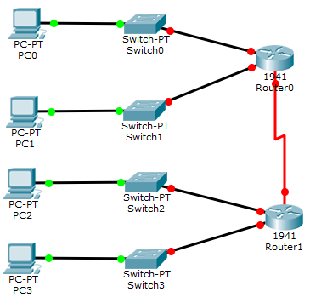

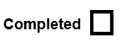

- We start out by enabling ipv6 unicast-routing and link-local addresses on both routers.
I have provided the commands for one of the routers in the topology.
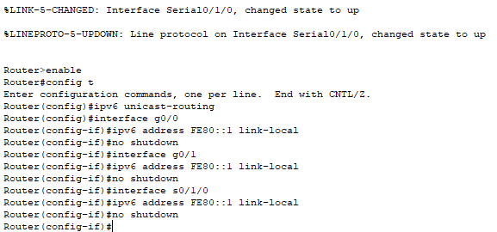

- Repeat the same commands on the other router.

- Start with the IPv6 subnet 2001:DB8:ACAD:00C8::/64 and assign it to the R1 LAN attached to GigabitEthernet 0/0.

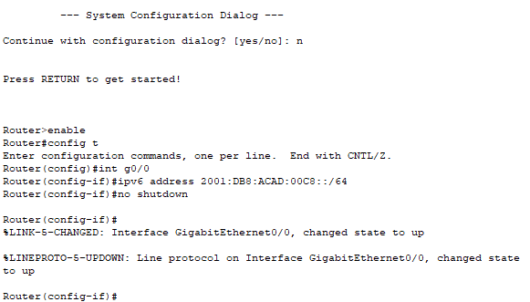

- For the rest of the IPv6 subnets on Router 0, increment the 2001:DB8:ACAD:00C8::/64 subnet address by 1.
Configure the interfaces as follows:

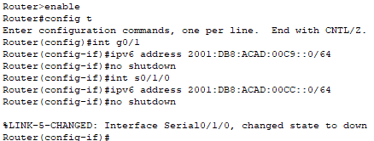

- Now configure the second router following the same basic steps we took on the first router.

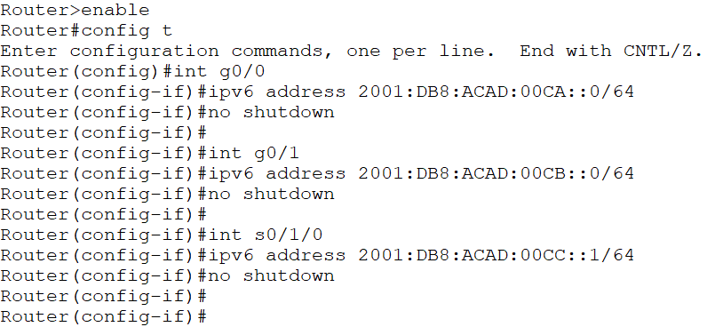

Follow up question

In step 6, you entered the no shutdown command. Was this command necessary?

Yes, it was necessary to bring up the router from being administratively down.

- If configured properly all your links should now be up and your network should look as follows:

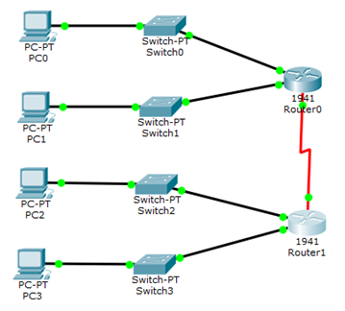

- We will now use autoconfig (SLAAC) to autoconfigure IPv6 addresses for the four terminals.
This is done by clicking on the PC, then clicking desktop, then IP Configuration.
From this menu, under the IPv6 menu, click the Auto Config radio button.

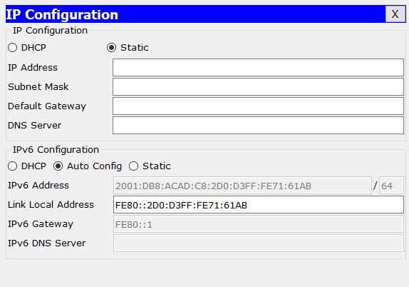

- We will now test your configurations to ensure they were set up properly.
To do this we now ping 2 PCs that are only on the same subnet. To make this happen, you will need to add another PC i.e. PC4 onto the same subnet as PC3 on the topology.
Provide a screenshot of your successful ping between PC3 and PC4 below.

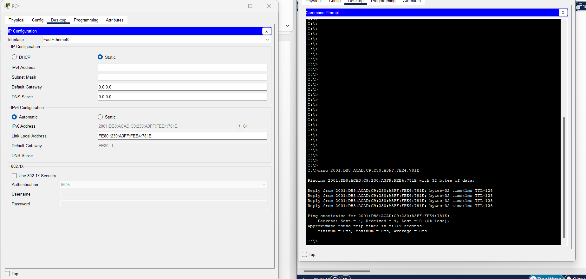

Important
Make sure you save your packet tracer file when you complete the lab as you will need it for Lab 44

